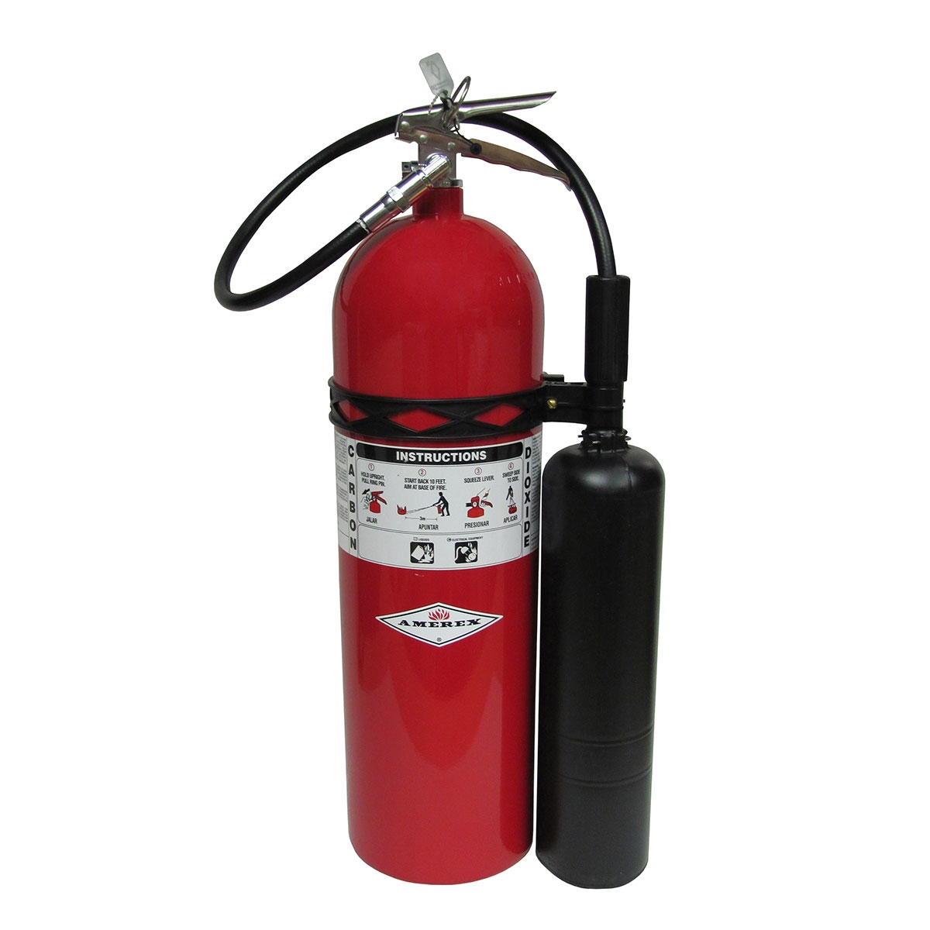

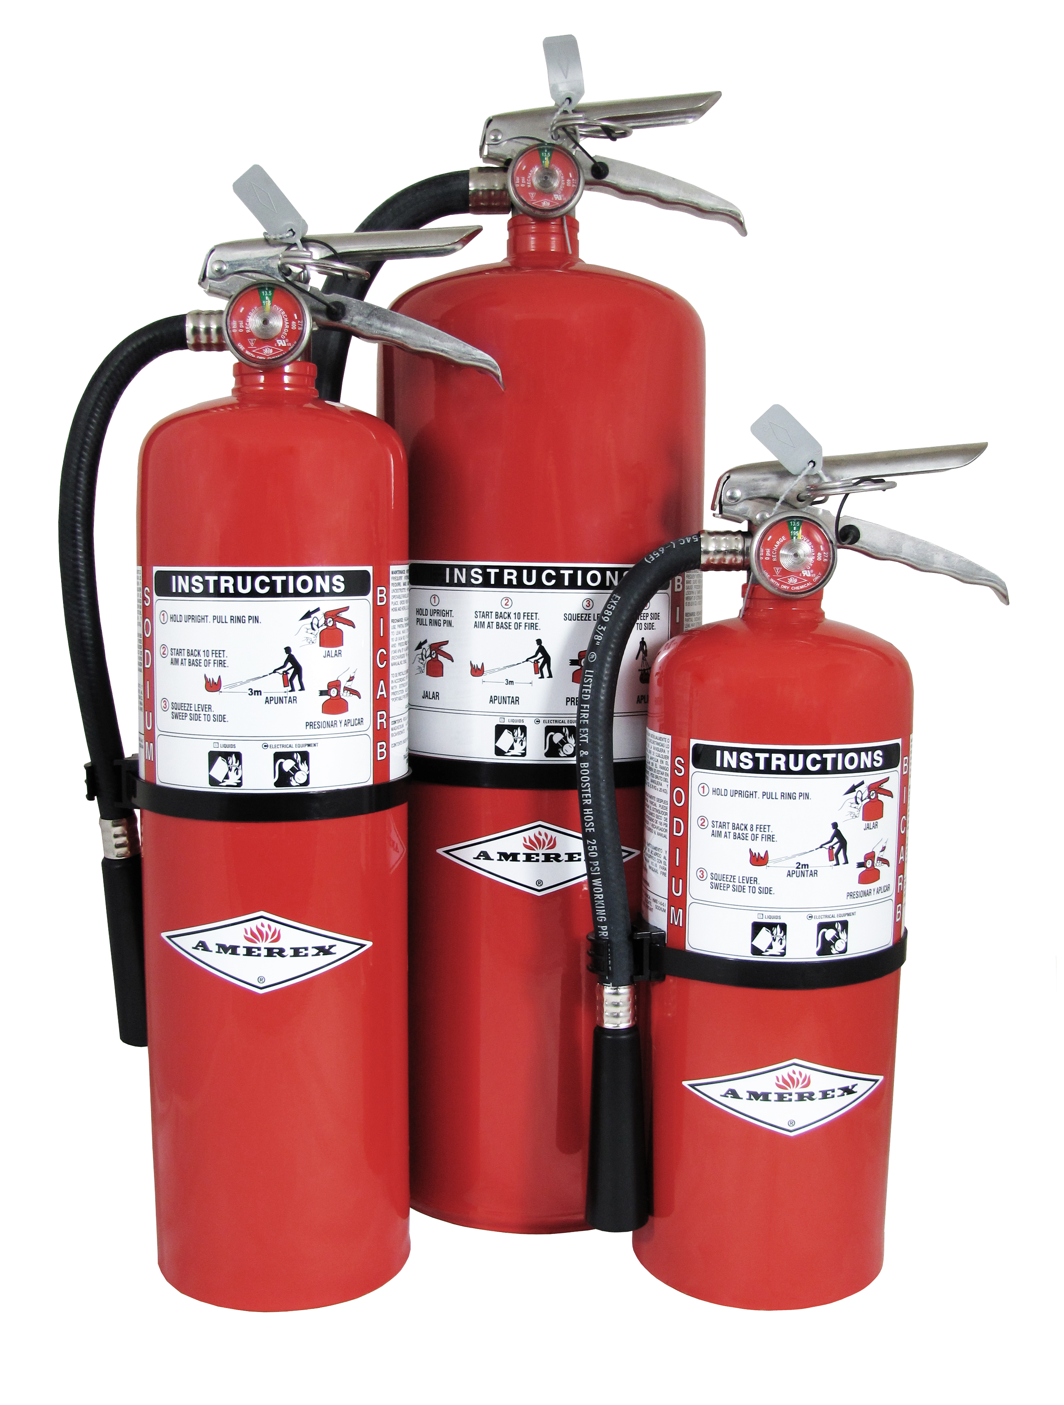



**WHAT:** “Hands-on” extinguisher training.

***Be prepared to go outside*.**

**WHEN:** **March 26**  
10:00 – 11:00 a.m. and 3:30 – 4:30 p.m.

**March 27**  
 6:30 a.m. – 7:30 a.m.

**WHERE:** Burson Conference Rooms A & B

**Employees are highly encouraged to attend one of the   
in-service sessions.**

**FIRE EXTINGUISHER  
TRAINING**

***Not all fires are the same – and neither are fire extinguishers.***   
  
There are several different categories of fires and it is important to know which extinguisher is the correct one to select during a fire hazard.  
  
**DID YOU KNOW THERE ARE MANY TYPES OF FIRE  
EXTINGUISHERS LOCATED AROUND THE HOSPITAL?**   
  
Join us for an employee in-service to learn how & when to   
use these extinguishers.